Navigation:
Code:
import React from 'react';
import { Navbar, Nav, Container, Button } from 'react-bootstrap';
import { Link, useNavigate } from 'react-router-dom';
import { useAuth } from '../contexts/AuthContext';

function Navigation() {
const { currentUser, logout } = useAuth();
const navigate = useNavigate();

const handleLogout = () => {
logout();
navigate('/');
};

return (
<Navbar bg="dark" variant="dark" expand="lg">
<Container>
<Navbar.Brand as={Link} to="/">Home</Navbar.Brand>
<Navbar.Toggle aria-controls="basic-navbar-nav" />
<Navbar.Collapse id="basic-navbar-nav">
<Nav className="me-auto">
<Nav.Link as={Link} to="/about">About</Nav.Link>
<Nav.Link as={Link} to="/news">News</Nav.Link>
<Nav.Link as={Link} to="/quiz">Quiz</Nav.Link>
<Nav.Link as={Link} to="/contact">Contact</Nav.Link>
</Nav>
<Nav>
{currentUser ? (
<>
<Navbar.Text className="me-2">
Xin chào, <strong>{currentUser.username}</strong>
</Navbar.Text>
<Button variant="outline-light" onClick={handleLogout}>
Đăng xuất
</Button>
</>
) : (
<Button as={Link} to="/login" variant="outline-light">
Đăng nhập
</Button>
)}
</Nav>
</Navbar.Collapse>
</Container>
</Navbar>
);
}

export default Navigation;

Result:
- Not logged
- Logged

Login Page:
Code:
import React, { useState, useEffect } from 'react';
import { Form, Button, Container, Card, Alert, Spinner } from 'react-bootstrap';
import { useAuth } from '../contexts/AuthContext';
import { useNavigate } from 'react-router-dom';

const Login = () => {
const [username, setUsername] = useState('');
const [password, setPassword] = useState('');
const [error, setError] = useState('');
const [isSubmitting, setIsSubmitting] = useState(false);
const { login, loading } = useAuth();
const navigate = useNavigate();

// Redirect if already logged in
useEffect(() => {
const user = JSON.parse(localStorage.getItem('user'));
if (user) {
navigate('/');
}
}, [navigate]);

const handleSubmit = async (e) => {
e.preventDefault();
setError('');

if (!username || !password) {
setError('Vui lòng nhập đầy đủ tên đăng nhập và mật khẩu');
return;
}

setIsSubmitting(true);

try {
const success = await login(username, password);
if (success) {
// Redirect to home page on successful login
navigate('/');
} else {
setError('Tên đăng nhập hoặc mật khẩu không chính xác');
}
} catch (error) {
setError('Có lỗi xảy ra khi đăng nhập. Vui lòng thử lại sau.');
console.error('Login error:', error);
} finally {
setIsSubmitting(false);
}
};

return (
<Container className="d-flex align-items-center justify-content-center" style={{ minHeight: '80vh' }}>
<Card className="w-100" style={{ maxWidth: '400px' }}>
<Card.Body>
<h2 className="text-center mb-4">Đăng nhập</h2>
{error && <Alert variant="danger">{error}</Alert>}
<Form onSubmit={handleSubmit}>
<Form.Group className="mb-3" controlId="formBasicEmail">
<Form.Label>Username</Form.Label>
<Form.Control
type="text"
placeholder="Nhập tên đăng nhập"
value={username}
onChange={(e) => setUsername(e.target.value)}
disabled={isSubmitting || loading}
required
/>
</Form.Group>

<Form.Group className="mb-3" controlId="formBasicPassword">
<Form.Label>Mật khẩu</Form.Label>
<Form.Control
type="password"
placeholder="Nhập mật khẩu"
value={password}
onChange={(e) => setPassword(e.target.value)}
disabled={isSubmitting || loading}
required
/>
</Form.Group>

<Button
variant="primary"
type="submit"
className="w-100"
disabled={isSubmitting || loading}
>
{isSubmitting || loading ? (
<>
<Spinner
as="span"
animation="border"
size="sm"
role="status"
aria-hidden="true"
className="me-2"
/>
Đang xử lý...
</>
) : (
'Đăng nhập'
)}
</Button>
</Form>
</Card.Body>
</Card>
</Container>
);
};

export default Login;

Result:
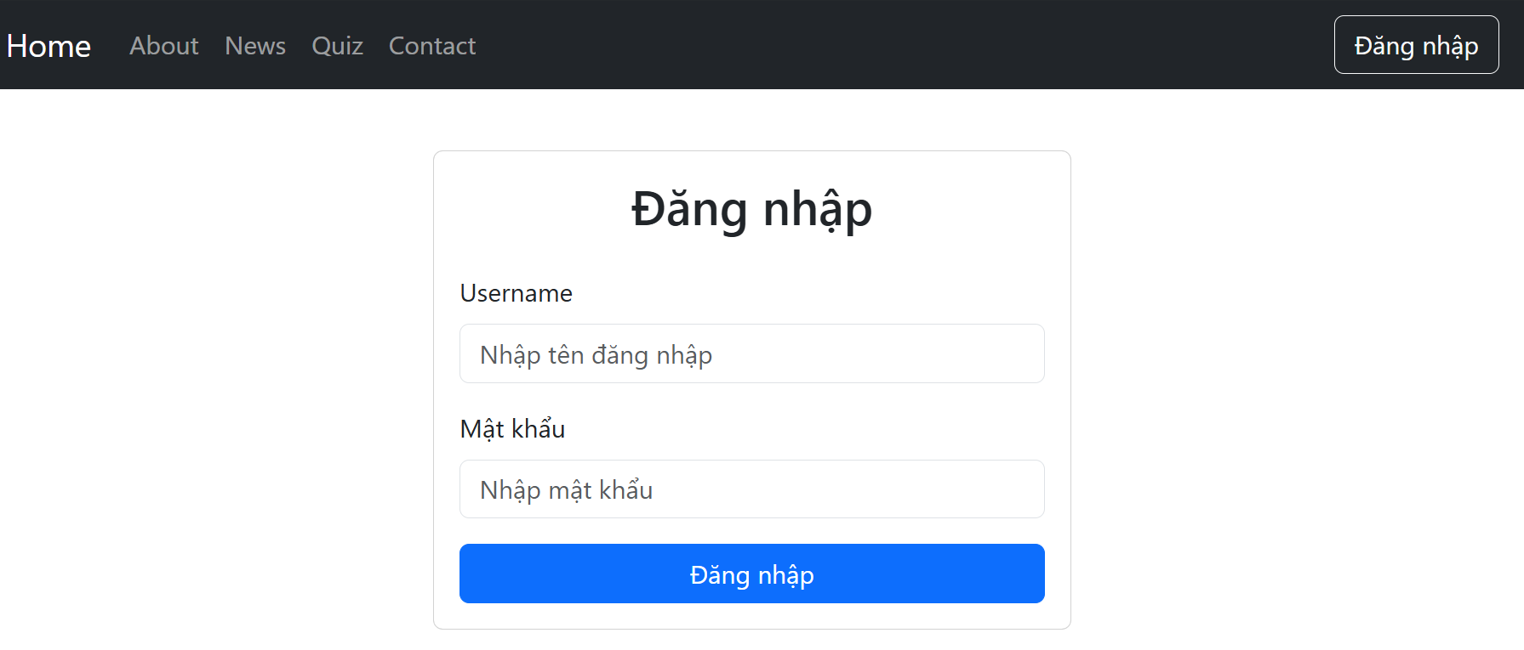

Home Page:
Code:
import React from 'react';
import { Carousel, Container } from 'react-bootstrap';
import slide1 from '../data/image/slide1.jpg';
import slide2 from '../data/image/slide2.jpg';
import slide3 from '../data/image/slide3.jpg';

const Home = () => {
return (
<Container fluid className="px-0">
<Carousel className="mb-5" style={{ width: '100%', maxWidth: '100%' }}>
<Carousel.Item>
<img
className="d-block w-100"
src={slide1}
alt="First slide"
style={{ width: '100%', height: '500px', objectFit: 'cover' }}
/>
<Carousel.Caption>
<h3>Test Your Knowledge</h3>
<p>Take our quizzes and challenge yourself!</p>
</Carousel.Caption>
</Carousel.Item>
<Carousel.Item>
<img
className="d-block w-100"
src={slide2}
alt="Second slide"
style={{ width: '100%', height: '500px', objectFit: 'cover' }}
/>
<Carousel.Caption>
<h3>Latest News</h3>
<p>Stay updated with our latest articles and updates.</p>
</Carousel.Caption>
</Carousel.Item>
<Carousel.Item>
<img
className="d-block w-100"
src={slide3}
alt="Third slide"
style={{ width: '100%', height: '500px', objectFit: 'cover' }}
/>
<Carousel.Caption>
<h3>Contact Us</h3>
<p>Have questions? Reach out to our team.</p>
</Carousel.Caption>
</Carousel.Item>
</Carousel>

<div className="row">
<div className="col-md-4 mb-4">
<div className="card h-100">
<div className="card-body">
<h5 className="card-title">Take a Quiz</h5>
<p className="card-text">Test your knowledge with our interactive quizzes on various topics.</p>
<a href="/quiz" className="btn btn-primary">Start Quiz</a>
</div>
</div>
</div>
<div className="col-md-4 mb-4">
<div className="card h-100">
<div className="card-body">
<h5 className="card-title">Read News</h5>
<p className="card-text">Stay updated with our latest articles and news updates.</p>
<a href="/news" className="btn btn-primary">View News</a>
</div>
</div>
</div>
<div className="col-md-4 mb-4">
<div className="card h-100">
<div className="card-body">
<h5 className="card-title">Contact Us</h5>
<p className="card-text">Have questions? Reach out to our support team.</p>
<a href="/contact" className="btn btn-primary">Contact</a>
</div>
</div>
</div>
</div>
</Container>
);
};

export default Home;

Result:
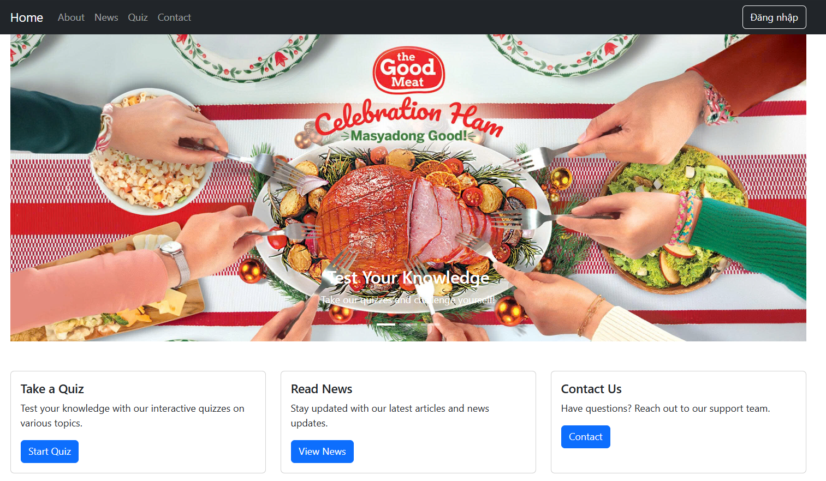
About Page:
Code:
import React from 'react';
import { Container, Row, Col, Card } from 'react-bootstrap';
import about_us from '../data/image/about_us.jpg';

const About = () => {
return (
<Container className="mt-4">
<h2 className="mb-4">About Our Online Quiz App</h2>

<Row className="mb-5">
<Col md={6}>
<h3>Our Mission</h3>
<p className="lead">
We are dedicated to providing an engaging and educational platform for users to test their knowledge
across various topics through interactive quizzes.
</p>
<p>
Our goal is to make learning fun and accessible to everyone, whether you're a student looking to
prepare for exams or someone who enjoys challenging themselves with trivia.
</p>
</Col>
<Col md={6}>
<img
src={about_us}
alt="About Us"
className="img-fluid rounded"
style={{ maxHeight: '300px', width: '100%', objectFit: 'cover' }}
/>
</Col>
</Row>

<h3 className="mb-4">Features</h3>
<Row className="g-4 mb-5">
<Col md={4}>
<Card className="h-100">
<Card.Body>
<Card.Title>Interactive Quizzes</Card.Title>
<Card.Text>
Test your knowledge with our wide range of quizzes on various topics. Each quiz is designed to be both challenging and educational.
</Card.Text>
</Card.Body>
</Card>
</Col>
<Col md={4}>
<Card className="h-100">
<Card.Body>
<Card.Title>Latest News</Card.Title>
<Card.Text>
Stay updated with our regularly updated news section featuring interesting articles and updates in the world of education and technology.
</Card.Text>
</Card.Body>
</Card>
</Col>
<Col md={4}>
<Card className="h-100">
<Card.Body>
<Card.Title>User-Friendly Interface</Card.Title>
<Card.Text>
Our intuitive design ensures a seamless experience for users of all ages and technical abilities.
</Card.Text>
</Card.Body>
</Card>
</Col>
</Row>

<div className="bg-light p-4 rounded mb-5">
<h4>Ready to test your knowledge?</h4>
<p className="mb-0">
Start exploring our quizzes today and challenge yourself to learn something new!
</p>
<a href="/quiz" className="btn btn-primary mt-3">Start Quiz</a>
</div>
</Container>
);
};

export default About;

Result:


News Page:
Code:
import React from 'react';
import { Card, Container, Row, Col } from 'react-bootstrap';
import news1 from '../data/image/news1.jpg';
import news2 from '../data/image/news2.jpg';
import news3 from '../data/image/news3.jpg';
import news4 from '../data/image/news4.jpg';
import news5 from '../data/image/news5.jpg';
import news6 from '../data/image/news6.jpg';
import news7 from '../data/image/news7.jpg';
import news8 from '../data/image/news8.jpg';

const newLists = [
{
id: 1,
title: 'Woman bakes expletive-laden pies to "get a rise" out of her grandmother in annual tradition',
description: '"What started as a means to get a rise out of my Grammy has snowballed into a weird family tradition," wrote Jess Lydon.',
images: news1
},
{
id: 2,
title: 'Martha Stewart shows off her 30 pies after canceled Thanksgiving dinner plans',
description: 'Queen of Thanksgiving Martha Stewart may not be hosting a turkey dinner this year but fret not, she will still be celebrating with literally 30 pies.',
images: news2
},
{
id: 3,
title: 'Burger King is testing a new breakfast sandwich',
description: 'This is a win for the flatbread fans.',
images: news3
},
{
id: 4,
title: 'Popeyes permanently adds chicken wings to its menu',
description: 'And you can get \'em in five different flavors.',
images: news4
},
{
id: 5,
title: 'Top salmon with a sizzling mix of aromatics and spices',
description: 'Tadka is a ubiquitous South Asian technique that adds a dramatic last-minute coat of flavor.',
images: news5
},
{
id: 6,
title: '80 Christmas dinner ideas for the ultimate holiday feast',
description: 'Build the perfect Christmas menu with these delicious recipes.',
images: news6
},
{
id: 7,
title: 'How to make the easiest prime rib roast for the holidays',
description: 'Use these tips and tricks to make a juicy and amazingly delicious prime rib roast.',
images: news7
},
{
id: 8,
title: 'Turn leftover turkey into a flavorful Waldorf salad',
description: 'This light, bright turkey salad is the best post-Thanksgiving lunch.',
images: news8
}
];

const News = () => {
return (
<Container>
<h2 className="mb-4">Latest News</h2>
<Row xs={1} md={2} lg={4} className="g-4">
{newLists.map((item) => (
<Col key={item.id}>
<Card className="h-100">
<Card.Img variant="top" src={item.images} alt={item.title} />
<Card.Body>
<Card.Title>{item.title}</Card.Title>
<Card.Text>{item.description}</Card.Text>
</Card.Body>
</Card>
</Col>
))}
</Row>
</Container>
);
};

export default News;

Result:
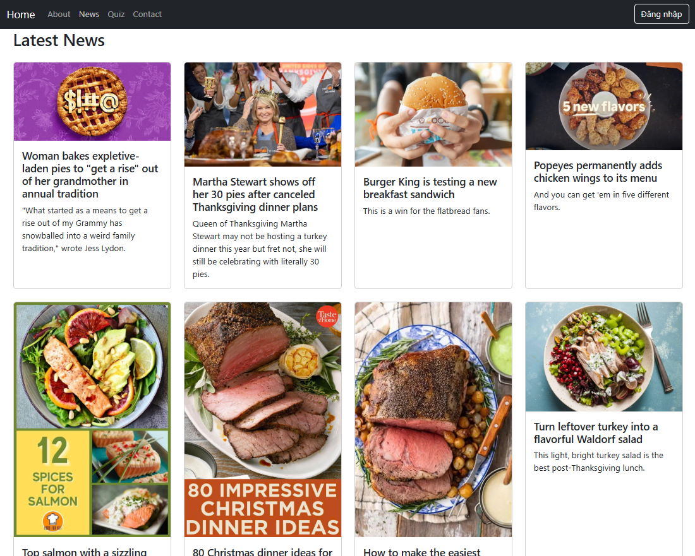

Quiz Page:
Code:
import React, { useState } from 'react';
import { Card, Button, Container, Form, Alert } from 'react-bootstrap';

const questions = [
{
id: 1,
question: 'What is the capital of France?',
options: ['London', 'Berlin', 'Paris', 'Madrid'],
correctAnswer: 'Paris'
},
{
id: 2,
question: 'Which planet is known as the Red Planet?',
options: ['Venus', 'Mars', 'Jupiter', 'Saturn'],
correctAnswer: 'Mars'
},
{
id: 3,
question: 'What is 2 + 2?',
options: ['3', '4', '5', '6'],
correctAnswer: '4'
}
];

const Quiz = () => {
const [currentQuestion, setCurrentQuestion] = useState(0);
const [selectedOption, setSelectedOption] = useState('');
const [score, setScore] = useState(0);
const [showResult, setShowResult] = useState(false);
const [quizCompleted, setQuizCompleted] = useState(false);

const handleOptionSelect = (option) => {
setSelectedOption(option);
};

const handleNext = () => {
if (selectedOption === questions[currentQuestion].correctAnswer) {
setScore(score + 1);
}

if (currentQuestion < questions.length - 1) {
setCurrentQuestion(currentQuestion + 1);
setSelectedOption('');
} else {
setShowResult(true);
setQuizCompleted(true);
}
};

const resetQuiz = () => {
setCurrentQuestion(0);
setSelectedOption('');
setScore(0);
setShowResult(false);
setQuizCompleted(false);
};

return (
<Container className="mt-4">
<h2 className="mb-4">Quiz</h2>
{!quizCompleted ? (
<Card>
<Card.Body>
<Card.Title>Question {currentQuestion + 1} of {questions.length}</Card.Title>
<Card.Text className="h5 mt-4">{questions[currentQuestion].question}</Card.Text>

<Form className="mt-4">
{questions[currentQuestion].options.map((option, index) => (
<Form.Check
key={index}
type="radio"
id={`option-${index}`}
label={option}
name="quiz-option"
checked={selectedOption === option}
onChange={() => handleOptionSelect(option)}
className="mb-3"
/>
))}
</Form>

<Button
variant="primary"
onClick={handleNext}
disabled={!selectedOption}
>
{currentQuestion === questions.length - 1 ? 'Finish Quiz' : 'Next'}
</Button>
</Card.Body>
</Card>
) : (
<Card>
<Card.Body className="text-center">
<h3>Quiz Completed!</h3>
<Alert variant="info" className="mt-3">
Your score: {score} out of {questions.length}
</Alert>
<Button variant="primary" onClick={resetQuiz} className="mt-3">
Retake Quiz
</Button>
</Card.Body>
</Card>
)}
</Container>
);
};

export default Quiz;

Result:
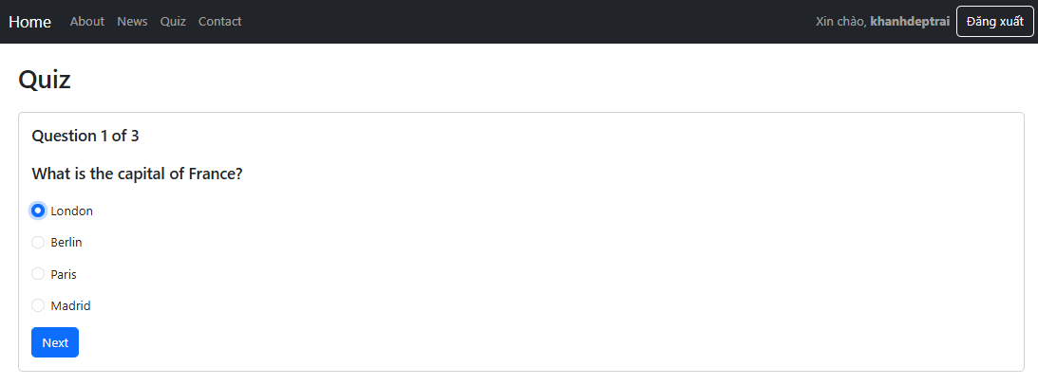
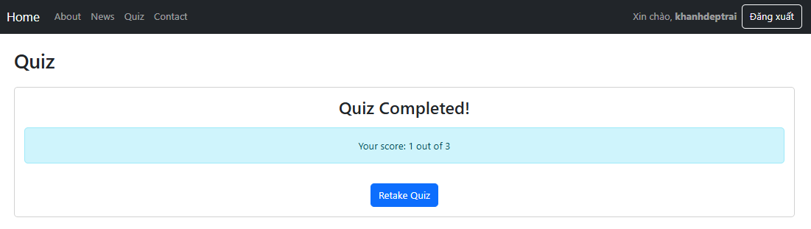
AuthContext.jsx:
Code:
import React, { createContext, useContext, useState, useEffect } from 'react';
import { useNavigate } from 'react-router-dom';

export const AuthContext = createContext();

export function useAuth() {
return useContext(AuthContext);
}

export function AuthProvider({ children }) {
const [currentUser, setCurrentUser] = useState(null);
const [authData, setAuthData] = useState(null);
const navigate = useNavigate();

// Load auth data from auth.json
useEffect(() => {
const loadAuthData = async () => {
try {
const response = await fetch('/auth.json');
const data = await response.json();
setAuthData(data);

// Check if user is logged in on initial load
const savedUser = JSON.parse(localStorage.getItem('auth'));
if (savedUser) {
// Verify the saved user still exists in auth data
const userExists = data.users.some(u => u.username === savedUser.username);
if (userExists) {
setCurrentUser(savedUser);
} else {
localStorage.removeItem('auth');
}
}
} catch (error) {
console.error('Error loading auth data:', error);
}
};

loadAuthData();
}, []);

const login = (username, password) => {
return new Promise((resolve) => {
if (!authData) {
resolve(false);
return;
}

// Find user in auth data
const user = authData.users.find(
u => u.username === username && u.password === password
);

if (user) {
const userData = {
id: user.id,
username: user.username,
};

localStorage.setItem('auth', JSON.stringify(userData));
setCurrentUser(userData);
resolve(true);
} else {
resolve(false);
}
});
};

const logout = () => {
localStorage.removeItem('auth');
setCurrentUser(null);
navigate('/login');
};

const value = {
currentUser,
login,
logout,
};

return (
<AuthContext.Provider value={value}>
{children}
</AuthContext.Provider>
);
}

ProtectedRoute.jsx: (
Code:
import React from 'react';
import { Navigate } from 'react-router-dom';
import { useAuth } from '../contexts/AuthContext';

export default function ProtectedRoute({ children }) {
const { currentUser } = useAuth();

if (!currentUser) {
// User not authenticated, redirect to login
return <Navigate to="/login" replace />;
}

return children;
}

App.jsx:
Code:
import React from 'react';
import { Routes, Route, Navigate } from 'react-router-dom';
import { Container } from 'react-bootstrap';
import { AuthProvider, useAuth } from './contexts/AuthContext';
import Navigation from './components/Navigation';
import Home from './components/Home';
import About from './components/About';
import News from './components/News';
import Quiz from './components/Quiz';
import Contact from './components/Contact';
import Login from './components/Login';
import ProtectedRoute from './components/ProtectedRoute';

function AppContent() {
const { user } = useAuth();

return (
<div>
<Navigation />
<Container>
<Routes>
<Route path="/" element={<Home />} />
<Route path="/about" element={<About />} />
<Route path="/news" element={<News />} />
<Route
path="/quiz"
element={
<ProtectedRoute>
<Quiz />
</ProtectedRoute>
}
/>
<Route path="/contact" element={<Contact />} />
<Route path="/login" element={user ? <Navigate to="/" /> : <Login />} />
</Routes>
</Container>
</div>
);
}

function App() {
return (
<AuthProvider>
<AppContent />
</AuthProvider>
);
}

export default App;

